Testing documentation

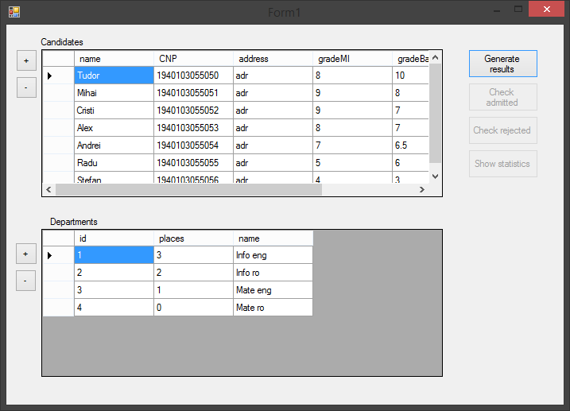
- Main application window

The main application window contains 2 data views that acquire their content at program startup, reading the candidate data from the “candidates.txt” file, and the department data from “departments.txt”file. The + buttons next to each view are used to add a new object to the database, bringing up a new form according depending on the candidate/department selection. The – buttons remove the selected row/item from the application database, according to the corresponding view. If no item is selected, a message box pops up with the message “No item was selected”.

The item data is modified straight from the data view, the data validation taking place when leaving the currently edited cell.
The department id and candidate CNP fields cannot be modified. The final grade field is automatically modified if one of the 2 grades has its value changed.
The following error messages show up based on the below cases:
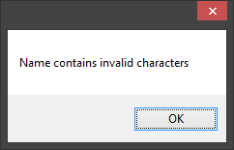
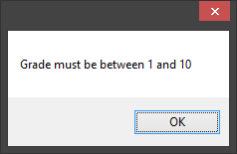
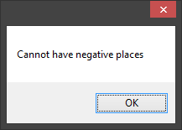
if the Candidate name contains numbers if a grade does not belong to the 1-10 interval if a department's places are of negative value

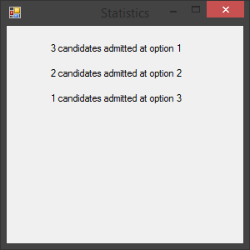
If the modified fields contain valid data, the items are automatically updated and passed on to the database ( printed to the file).
By pressing the “Generate results” button, the app generates a Result object, containing the lists of admitted and rejected students, and statistics concerning them. The lists are placed in 2 text files, “admitted.txt”, containing candidate names and their corresponding department, and “rejected.txt”containing the rejected candidates names. The files can be viewed using the “Check admitted” and “Check rejected” buttons, made available after result generation.
The “Show statistics” button shows the number of candidates admitted,using the statistics field in the generated Result object, ranked by the priority of their department in their initial selected departments. A form pop-up is created, an example of which can be seen to the left. The button is only made available after result generation.

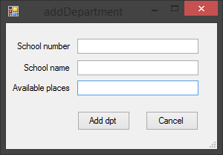
2. The department add form

- is brought up when the department view + button is clicked
- if the data is valid (school number doesn't already exist, available places are 0 or greater), a new Department is created and added to the list by pressing the “Add dpt” button. Else, a corresponding error box is shown.

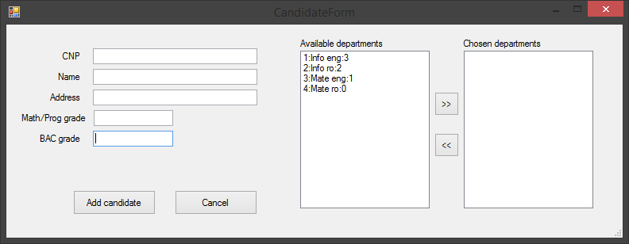
- The candidate add form
  - Is brought up if the main form's + (add candidate) button is clicked
  - Departments are chosen using the arrow buttons. They are ranked from to bottom according to their priority (e.g upper-most option is the most preffered one, the next one is second, etc.)
  - Data validation criteria:
    - A student with the same CNP cannot already exist in the database
    - CNP must be 13 characters long, only digits
    - the name cannot contain digits
    - both grades need to be between 1 and 10
    - the “Chosen departments” list cannot be empty
  - If the data is valid, a new Candidate is created and added to the database by pressing the “Add candidate” button.
  - Else , a corresponding error message box is shown, as can be seen below.
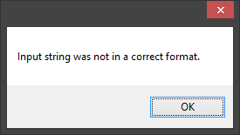
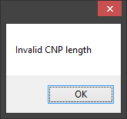
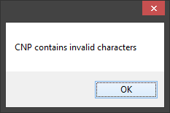

Basic user manual

- Run application
- preexisting data is loaded into the application at startup

- To add a candidate, click the + button next to the candidates list, then insert all the candidate data into the fields. Select your desired departments in descending order of importance. An error message will pop-up if a field contains wrong data, or if there is something wrong with your department selection.
- To remove a candidate, select one from the view, then click the – button next to the view. If no candidate is selected, an error message will be shown.
- To modify a candidate, simply select a cell in the data table and change its value. If the new value isn't valid , an error message will be shown.

- To add a department, click the + button next to the department list, then insert all the data into the fields. An error message will pop-up if a field contains wrong data.
- To remove a department select one from the view, then click the – button next to the view. If no department is selected, an error message will be shown.
- To modify a department, simply select a cell in the data table and change its value. If the new value isn't valid , an error message will be shown

- To see the admitted/rejected students, click the “Generate results” button, then “Check admitted” for the admitted list, and “Check rejected” for the rejected list.
- To see the admittance statistics, click the “Show statistics” button.

